
Sri Lanka Institute of Information Technology

Year 2 Semester 1
Lab Sheet 10

<IT24101932>
<Jayasekara W.K.R.>

Probability and Statistics - IT2120
B.Sc. (Hons) in Information Technology

Question 01
i.
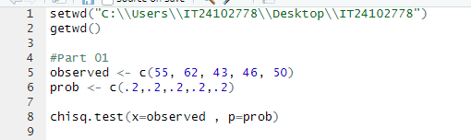
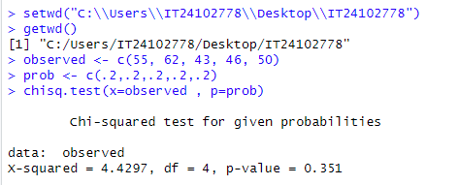
ii.
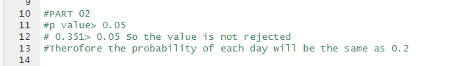
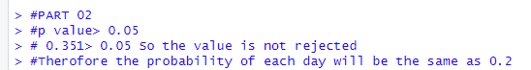

Question 02
i.
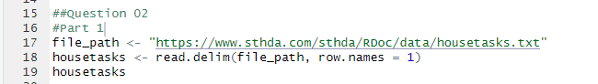
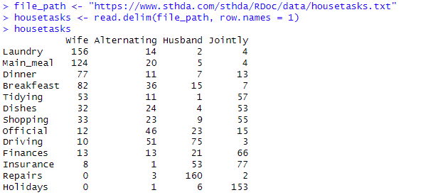
ii.
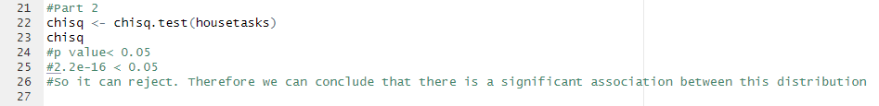

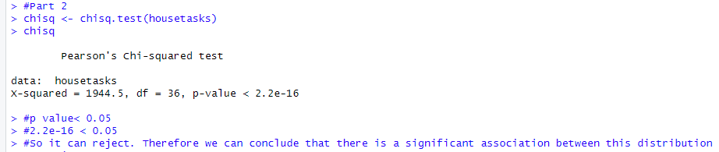

Exercise
